# Learning about urban climate solutions

# Supplementary information

William F. Lamb1*, Felix Creutzig1,2, Max W. Callaghan1,3, Jan C. Minx1,3

1 Mercator Research Institute on Global Commons and Climate Change, Torgauer Straße 12-15, EUREF Campus #19, 10829 Berlin, Germany

2 Technische Universität Berlin, Straße des 17. Juni 135, 10623 Berlin, Germany

3 School of Earth and Environment, University of Leeds, Leeds LS2 9JT, UK

* [lamb@mcc-berlin.net](mailto:lamb@mcc-berlin.net)

## Additional Figures and Tables

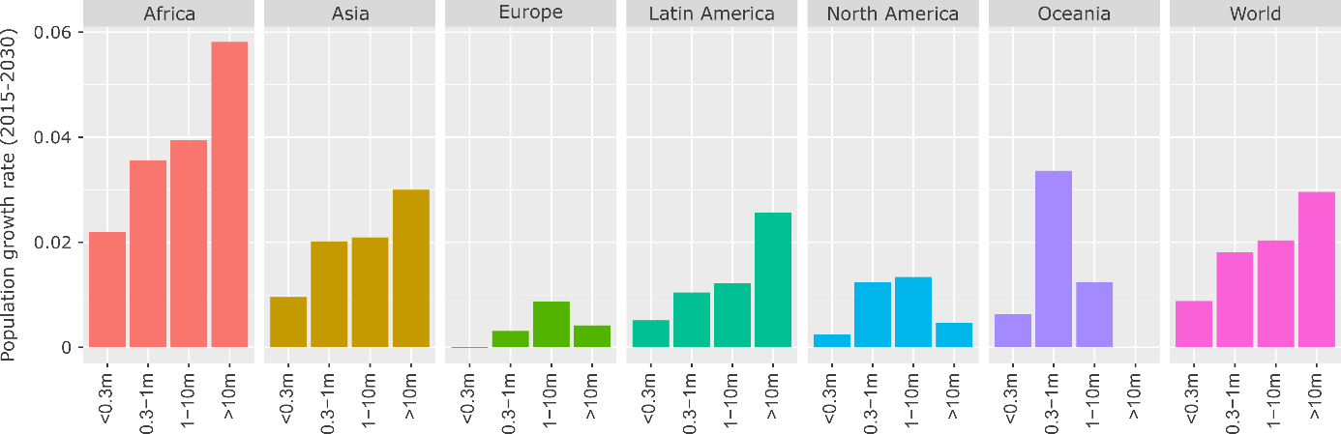

**Figure 1: Projected population growth rate by region and city size, 2015-2030.** Population data from ref 1, using agglomeration data where available.

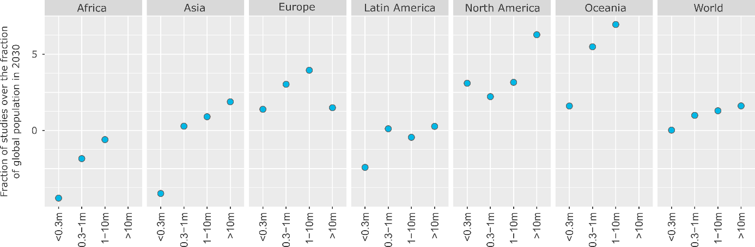

**Figure 2: The global distribution of urban case studies versus population size**. To normalise, where the numerator (% of global population in a region & city size) exceeds the denominator (% of case studies in a region & city size), we subtract the fraction from 2. Population data from ref 1, using agglomeration data where available.

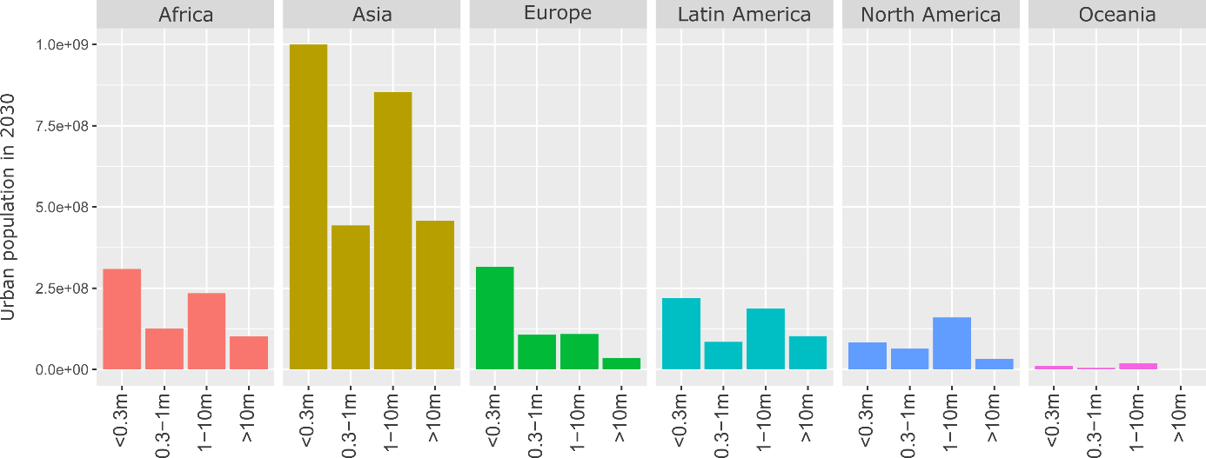

**Figure 3: Total urban population in 2030 by region and city size.** Population data from ref 1, using agglomeration data where available.

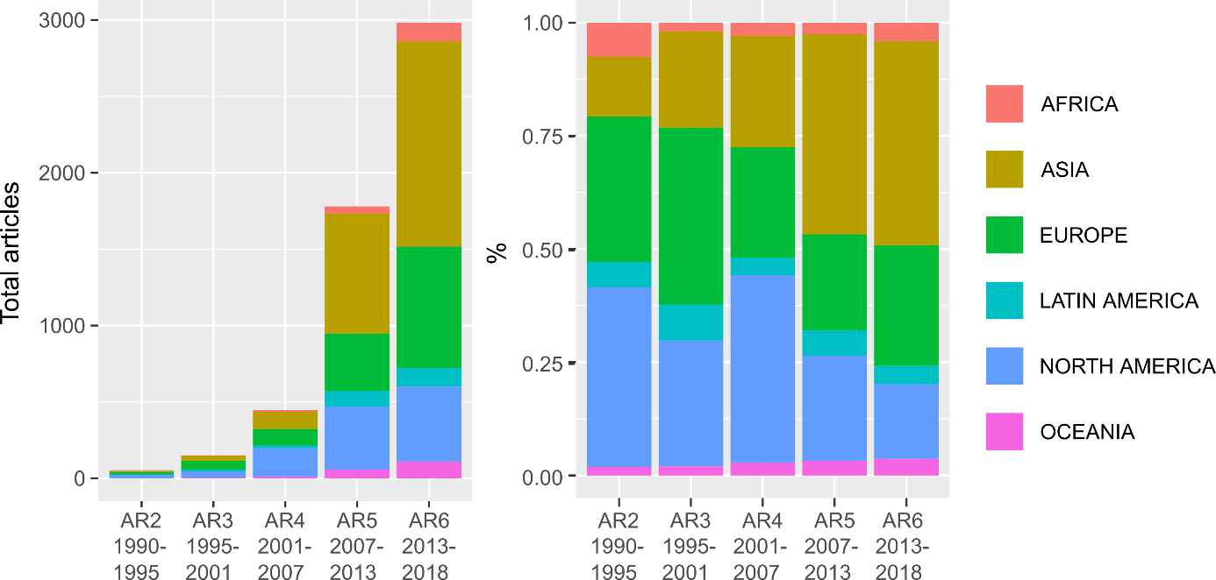

**Figure 4: Total articles and regional proportions of case study literature by IPCC Assessment Period**

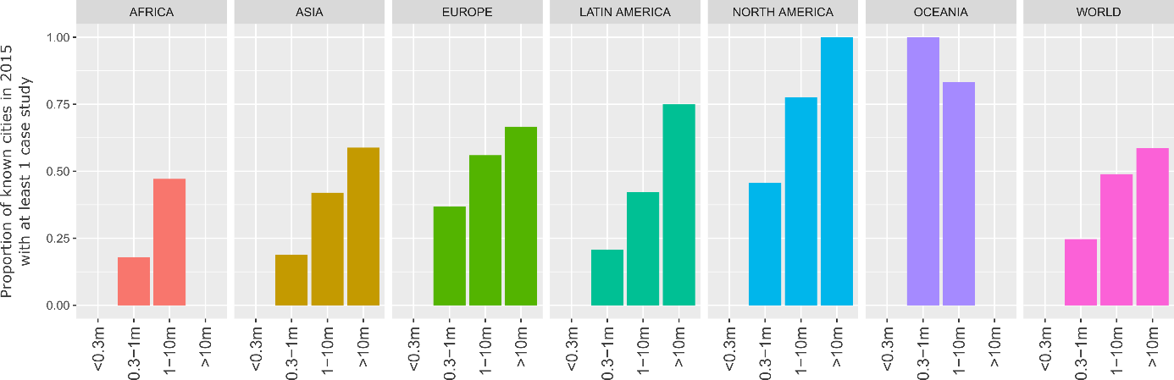

**Figure 5: Direct coverage of case studies.** Missing values for small cities are due to absent data; missing values for mega-cities (Africa, Oceania) indicate no documented mega-cities in these regions as of 2015. Population data from ref 1, using agglomeration data where available.

|  |  |  |  |
| --- | --- | --- | --- |
| **ID** | **Topic Name** | **Stemmed Keywords** | **Marginal Topic Distribution (%)** |
| 1 | Climate governance | climat; chang; polici; local; govern | 8.9 |
| 2 | Energy use | energi; consumpt; effici; sector; renew | 8.0 |
| 3 | Energy systems | system; electr; power; cost; generat | 7.4 |
| 4 | Urban form | urban; land; area; model; ecolog | 7.3 |
| 5 | Buildings | build; energi; design; residenti; perform | 6.8 |
| 6 | CO2 emissions | carbon; emiss; industri; low; intens | 6.7 |
| 7 | GHG emissions | emiss; ghg; reduct; greenhous; gas | 6.3 |
| 8 | Cooling demand | air; temperatur; cool; roof; climat | 6.3 |
| 9 | Transportation | transport; traffic; travel; public; car | 5.8 |
| 10 | Vehicles | vehicl; fuel; electr; charg; drive | 5.0 |
| 11 | Households | household; incom; behavior; survey; resid | 4.7 |
| 12 | Waste management | wast; landfil; solid; recycl; manag | 4.7 |
| 13 | Heat demand | heat; district; thermal; pump; network | 4.6 |
| 14 | Water demand | water; suppli; treatment; manag; wastewat | 4.3 |
| 15 | Renewable energy | solar; radiat; energi; photovolta; collector | 3.8 |
| 16 | Urban ecology | tree; forest; benefit; speci; plant | 3.4 |

**Table 1: List of topics and their keywords.** Topic names are manually coded by the authors based on a review of the stemmed keywords and associated documents. The marginal topic distribution denotes the percentage of the document set where this topic is found. One topic was manually removed (keywords: lowcarbon; develop; industri; economi; citi) as this is largely synonymous in content with ‘CO2 emissions’ and is only relevant for a specific (but large) subset of studies in China.

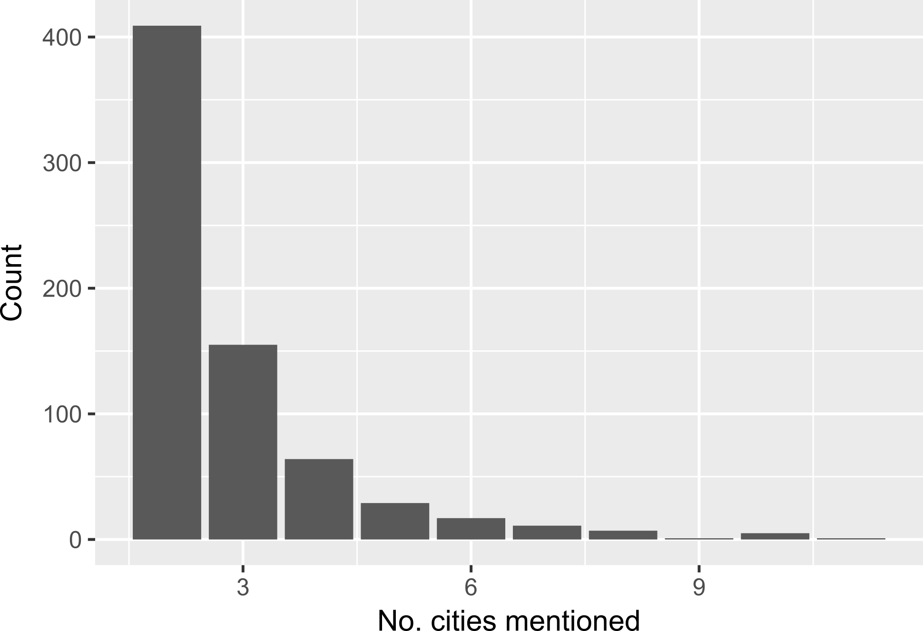

Figure 6: Number of cities mentioned in comparative studies

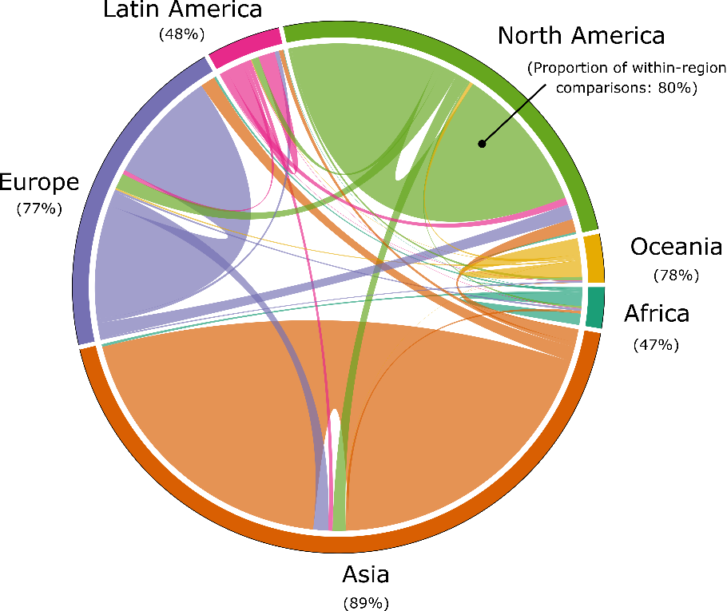

**Figure 7: Inter and intra-regional comparative research on urban climate mitigation.** Each link in the chord diagram is based on the pairwise coupling of two cities within a document. Documents where more than one city is mentioned in the abstract are used, totalling 699 studies. The proportion of regional couplings that pair with other regions (i.e. inter-regional urban comparisons) are indicated as percentages.

|  |  |  |  |
| --- | --- | --- | --- |
| **Authors** | **Year** | **Title** | **Topics** |
| Khalil, H.A.E.E. | 2009 | Energy efficiency strategies in urban planning of cites | Buildings; Climate governance; energy use; urban form |
| Attia, S & De Herde, A | 2010 | Active solar retrofit of a residential house, A case study in Egypt | Buildings; Heat demand; Cooling demand; Renewable energy |
| Fahmy, M & Sharples, S | 2011 | Urban form, thermal comfort and building CO2 emissions - a numerical analysis in Cairo | Buildings; GHG emissions; Cooling demand; Urban form |
| El-Deeb, K, El-Zafarany, A & Sherif, A | 2012 | Effect of building form and urban pattern : On energy consumption of residential buildings in different desert climates | Buildings; Urban form |
| Verdeil, E, Arik, E, Bolzon, H & Markoum, J | 2015 | Governing the transition to natural gas in Mediterranean Metropolis: The case of Cairo, Istanbul and Sfax (Tunisia) | Climate governance; Energy use; Heat demand; Renewable energy; Urban form |
| Dabaieh, M, Wanas, O, Hegazy, MA & Johansson, E | 2015 | Reducing cooling demands in a hot dry climate: A simulation study for non-insulated passive cool roof thermal performance in residential buildings | Buildings; Cooling demand |
| Kares, M & Singh, P | 2016 | Assessment of building integrated photovoltaics for the residential section in representative Urban areas in Egypt | Buildings; Energy use; Households; Renewable energy; Urban form |
| Aboulnaga, M. | 2016 | High-rise buildings in context of sustainability; urban metaphors of greater Cairo, Egypt: A case study on sustainability and strategic environmental assessment | Buildings |
| Chen, H &  Dietrich, U | 2017 | Land-use planning for zero-energy-buildings: Comparison of four high-density cities | Energy use; Urban form |

**Table 2: Urban climate mitigation literature on Cairo**

|  |  |  |
| --- | --- | --- |
| **Title** | **Method** | **Ref** |
| The neglected social dimensions to a vehicle-to-grid (V2G) transition: a critical and systematic review | Systematic review | 2 |
| Interdependence between Urban Processes and Energy Transitions: The Urban Energy Transitions (DUET) Framework | Case meta-analysis | 3 |
| Decarbonising transport to achieve Paris Agreement targets | Quantitative synthesis | 4 |
| Green roofs against pollution and climate change. A review | Narrative review | 5 |
| Urban and peri-urban agriculture and forestry: Transcending poverty alleviation to climate change mitigation and adaptation | Narrative review | 6 |
| Prospects and challenges for sustainable sanitation in developed nations: a critical review | Narrative review | 7 |
| A meta-analysis of urban and peri-urban agriculture and forestry in mediating climate change | Narrative review | 8 |
| A review on co-benefits of mass public transportation in climate change mitigation | Narrative review | 9 |
| What do we know about the study of distributed generation policies and regulations in the Americas? A systematic review of literature | Bibliometric study | 10 |
| Co-benefits of greenhouse gas mitigation: a review and classification by type, mitigation sector, and geography | Bibliometric study & narrative review | 11 |
| Benefits of green roofs: A systematic review of the evidence for three ecosystem services | Quantitative synthesis | 12 |
| Assessing the success of electricity demand response programs: A meta-analysis | Meta-analysis | 13 |
| The economic benefits and costs of trees in urban forest stewardship: A systematic review | Bibliometric study, quantitative synthesis & narrative review | 14 |

**Table** 3**:** **Systematic reviews of urban climate change mitigation.** The minimum criteria for a ‘systematic review’ here is the formal selection of literature via a database search query. Some reviews (10,11,13) focus on non-urban issues, but derive important conclusions for scientific learning at urban scale, and thus should be included in the relevant literature base on urban-scale climate change mitigation. See methods for our identification procedure.

|  |  |  |  |
| --- | --- | --- | --- |
|  |  |  |  |
|  |  |  |  |
| **Topic** | **Proportion (%)** | **Topic** | **Proportion** |
| GHG emissions | 9.6 | Waste management | 5.5 |
| Climate governance | 8.9 | Vehicles | 4.3 |
| Energy consumption | 8.3 | Heat demand | 3.9 |
| Transportation | 7.5 | Renewable energy | 3.8 |
| Air pollution | 7.5 | Water demand | 3.5 |
| CO2 emissions | 6.9 | Urban ecology | 2.9 |
| Buildings | 5.8 | Cooling demand | 2.7 |
| Urban form | 5.7 | Households | 2.6 |

**Table 4: Topic proportions of 'forward-looking' case studies**

|  |  |  |  |
| --- | --- | --- | --- |
| **Region** | **No. case studies** | **No. ‘forward-looking’ studies** | **Proportion (%)** |
| Africa | 158 | 12 | 8 |
| Asia | 1934 | 335 | 17 |
| Europe | 1145 | 227 | 19 |
| Latin America | 206 | 37 | 18 |
| North America | 1054 | 131 | 12 |
| Oceania | 151 | 23 | 15 |

**Table 5: Regional coverage of 'forward-looking' case studies**

Bibliography

1. UN DESA. *World Urbanization Prospects: The 2018 Revision*. (United Nations, Department of Economic and Social Affairs, Population Division, 2018).

2. Sovacool, B. K., Noel, L., Axsen, J. & Kempton, W. The neglected social dimensions to a vehicle-to-grid (V2G) transition: A critical and systematic review. *Environ. Res. Lett.* **13,** (2018).

3. Huang, P. & Castán Broto, V. Interdependence between Urban Processes and Energy Transitions: The Urban Energy Transitions (DUET) Framework. *Environ. Innov. Soc. Transitions* **28,** 35–45 (2018).

4. Gota, S., Huizenga, C., Peet, K., Medimorec, N. & Bakker, S. Decarbonising transport to achieve Paris Agreement targets. *Energy Effic.* 1–24 (2018). doi:10.1007/s12053-018-9671-3

5. Li, Y. & Babcock, R. W. Green roofs against pollution and climate change. A review. *Agron. Sustain. Dev.* **34,** 695–705 (2014).

6. Lwasa, S. *et al.* Urban and peri-urban agriculture and forestry: Transcending poverty alleviation to climate change mitigation and adaptation. *Urban Clim.* **7,** 92–106 (2014).

7. Brands, E. Prospects and challenges for sustainable sanitation in developed nations: a critical review. *Environ. Rev.* **22,** 346–363 (2014).

8. Lwasa, S. *et al.* A meta-analysis of urban and peri-urban agriculture and forestry in mediating climate change. *Curr. Opin. Environ. Sustain.* **13,** 68–73 (2015).

9. Kwan, S. C. & Hashim, J. H. A review on co-benefits of mass public transportation in climate change mitigation. *Sustain. Cities Soc.* **22,** 11–18 (2016).

10. Garcez, C. A. G. What do we know about the study of distributed generation policies and regulations in the Americas? A systematic review of literature. *Renew. Sustain. Energy Rev.* **75,** 1404–1416 (2017).

11. Deng, H.-M., Liang, Q.-M., Liu, L.-J. & Anadon, L. D. Co-benefits of greenhouse gas mitigation: a review and classification by type, mitigation sector, and geography. *Environ. Res. Lett.* **12,** (2018).

12. Francis, L. F. M. & Jensen, M. B. Benefits of green roofs: A systematic review of the evidence for three ecosystem services. *Urban For. Urban Green.* **28,** 167–176 (2017).

13. Srivastava, A., Van Passel, S. & Laes, E. Assessing the success of electricity demand response programs: A meta-analysis. *Energy Res. Soc. Sci.* **40,** 110–117 (2018).

14. Song, X. P., Tan, P. Y., Edwards, P. & Richards, D. The economic benefits and costs of trees in urban forest stewardship: A systematic review. *Urban For. Urban Green.* **29,** 162–170 (2018).